1. **Implement Bresenham’s Line Drawing Algorithm**

import matplotlib.pyplot as plt

def bresenham_line(x1, y1, x2, y2):

    points = []

    dx = abs(x2 - x1)

    dy = abs(y2 - y1)

    sx = 1 if x2 > x1 else -1

    sy = 1 if y2 > y1 else -1

    err = dx - dy

    while True:

        points.append((x1, y1))

        if x1 == x2 and y1 == y2:

            break

        e2 = 2 * err

        if e2 > -dy:

            err -= dy

            x1 += sx

        if e2 < dx:

            err += dx

            y1 += sy

    return points

def main():

    print("Bresenham's Line Drawing Algorithm")

    try:

        x1 = int(input("Enter x1: "))

        y1 = int(input("Enter y1: "))

        x2 = int(input("Enter x2: "))

        y2 = int(input("Enter y2: "))

        points = bresenham_line(x1, y1, x2, y2)

        # Extract x and y coordinates

        x_coords, y_coords = zip(*points)

        # Plotting the line

        plt.plot(x_coords, y_coords, marker='o', color='blue')

        plt.title("Bresenham's Line Drawing")

        plt.xlabel("X-axis")

        plt.ylabel("Y-axis")

        plt.grid(True)

        plt.gca().set_aspect('equal', adjustable='box')

        plt.show()

    except ValueError:

        print("Please enter valid integer values.")

if __name__ == "__main__":

    main()

**OUTPUT**

Bresenham's Line Drawing Algorithm

Enter x1: 4

Enter y1: 5

Enter x2: 13

Enter y2: 16

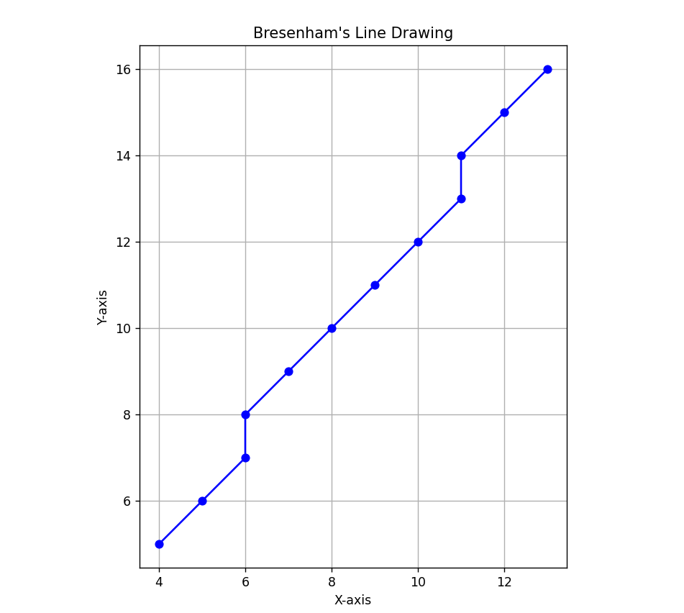

1. **Implement Cohen-Sutherland Line Clipping Algorithm**

import matplotlib.pyplot as plt

INSIDE, LEFT, RIGHT, BOTTOM, TOP = 0, 1, 2, 4, 8

def compute_code(x, y, rect):

    xmin, xmax, ymin, ymax = rect

    return (LEFT if x < xmin else RIGHT if x > xmax else 0) | \

           (BOTTOM if y < ymin else TOP if y > ymax else 0)

def clip_line(x1, y1, x2, y2, rect):

    code1, code2 = compute_code(x1, y1, rect), compute_code(x2, y2, rect)

    while True:

        if not (code1 | code2):

            return x1, y1, x2, y2

        elif code1 & code2:

            return None

        out = code1 or code2

        xmin, xmax, ymin, ymax = rect

        if out & TOP:     x = x1 + (x2 - x1) * (ymax - y1)/(y2 - y1); y = ymax

        elif out & BOTTOM:x = x1 + (x2 - x1) * (ymin - y1)/(y2 - y1); y = ymin

        elif out & RIGHT: y = y1 + (y2 - y1) * (xmax - x1)/(x2 - x1); x = xmax

        elif out & LEFT:  y = y1 + (y2 - y1) * (xmin - x1)/(x2 - x1); x = xmin

        if out == code1: x1, y1, code1 = x, y, compute_code(x, y, rect)

        else:            x2, y2, code2 = x, y, compute_code(x, y, rect)

def main():

    print("Cohen–Sutherland Line Clipping")

    x1, y1 = map(float, input("Enter x1 y1: ").split())

    x2, y2 = map(float, input("Enter x2 y2: ").split())

    rect = tuple(map(float, input("Enter xmin xmax ymin ymax: ").split()))

    clipped = clip_line(x1, y1, x2, y2, rect)

    fig, ax = plt.subplots()

    ax.add_patch(plt.Rectangle((rect[0], rect[2]), rect[1]-rect[0], rect[3]-rect[2], edgecolor='black', fill=False, linestyle='--'))

    ax.plot([x1, x2], [y1, y2], 'r--', label="Original Line")

    if clipped:

        ax.plot([clipped[0], clipped[2]], [clipped[1], clipped[3]], 'g-', label="Clipped Line")

    else:

        print("Line is completely outside the clipping window.")

    plt.title("Cohen–Sutherland Line Clipping")

    plt.xlabel("X"); plt.ylabel("Y"); plt.grid(True); plt.axis('equal'); plt.legend()

    plt.show()

if __name__ == "__main__":

    main()

**OUTPUT**

Cohen–Sutherland Line Clipping

Enter x1 y1: 30 30

Enter x2 y2: 250 250

Enter xmin xmax ymin ymax: 50 200 50 200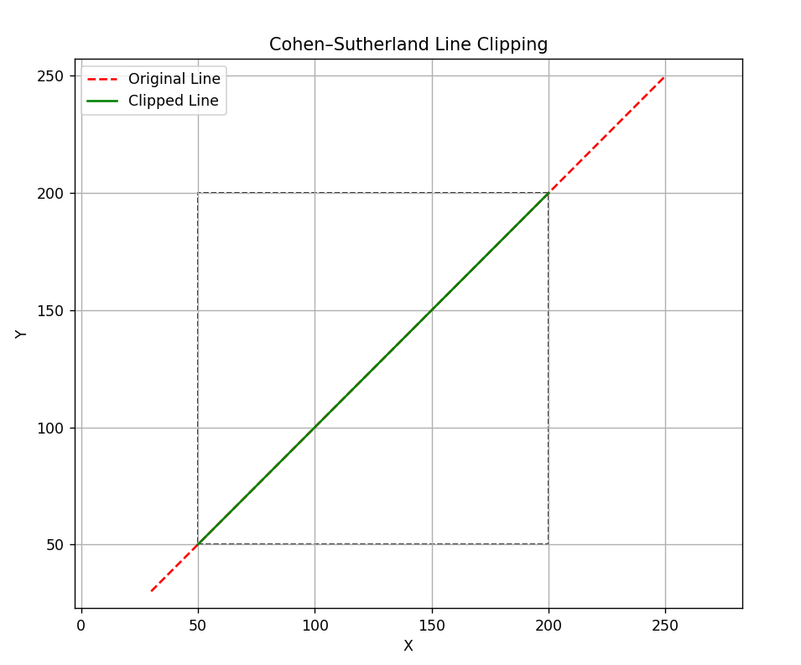

1. **Implement Midpoint Circle Drawing Algorithm**

import matplotlib.pyplot as plt

def plot_circle_points(xc, yc, x, y, points):

    # 8-way symmetry

    points.extend([

        (xc + x, yc + y),

        (xc - x, yc + y),

        (xc + x, yc - y),

        (xc - x, yc - y),

        (xc + y, yc + x),

        (xc - y, yc + x),

        (xc + y, yc - x),

        (xc - y, yc - x)

    ])

def midpoint_circle(xc, yc, r):

    x = 0

    y = r

    d = 1 - r

    points = []

    while x <= y:

        plot_circle_points(xc, yc, x, y, points)

        if d < 0:

            d = d + 2 * x + 3

        else:

            d = d + 2 * (x - y) + 5

            y -= 1

        x += 1

    return points

def main():

    print("Midpoint Circle Drawing Algorithm")

    try:

        xc = int(input("Enter center x-coordinate: "))

        yc = int(input("Enter center y-coordinate: "))

        r = int(input("Enter radius: "))

        if r < 0:

            raise ValueError("Radius must be non-negative.")

        points = midpoint_circle(xc, yc, r)

        # Extract x and y coordinates

        x_coords, y_coords = zip(*points)

        # Plotting the circle

        plt.scatter(x_coords, y_coords, color='purple')

        plt.title("Midpoint Circle Drawing")

        plt.xlabel("X-axis")

        plt.ylabel("Y-axis")

        plt.grid(True)

        plt.gca().set_aspect('equal', adjustable='box')

        plt.show()

    except ValueError as e:

        print("Error:", e)

if __name__ == "__main__":

    main()

**OUTPUT**

Midpoint Circle Drawing Algorithm

Enter center x-coordinate: -3

Enter center y-coordinate: 1

Enter radius: 13

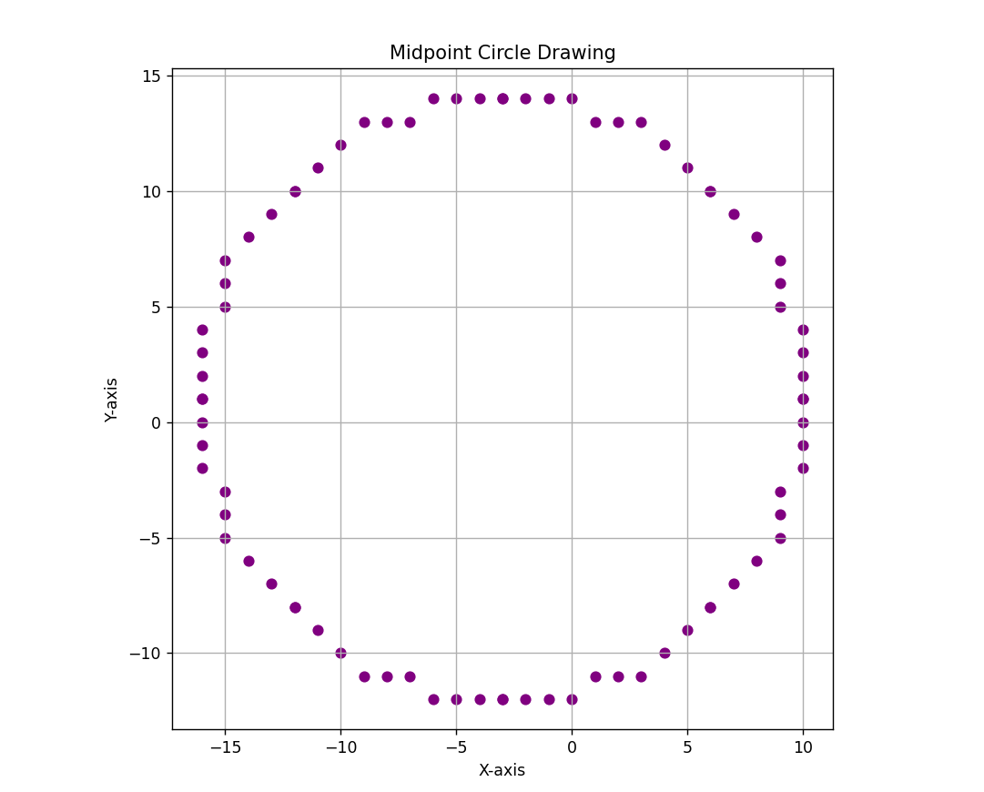

1. **Polygon Clipping using Sutherland-Hodgman Algorithm**

import matplotlib.pyplot as plt

def inside(p, edge, rect):

    x, y = p; xmin, xmax, ymin, ymax = rect

    return (x >= xmin if edge == 'LEFT' else

            x <= xmax if edge == 'RIGHT' else

            y >= ymin if edge == 'BOTTOM' else

            y <= ymax)

def intersect(p1, p2, edge, rect):

    x1, y1 = p1; x2, y2 = p2; xmin, xmax, ymin, ymax = rect

    dx, dy = x2 - x1, y2 - y1

    if dx == 0: m = float('inf')

    else: m = dy / dx

    if edge == 'LEFT': return (xmin, y1 + m * (xmin - x1))

    if edge == 'RIGHT': return (xmax, y1 + m * (xmax - x1))

    if edge == 'BOTTOM': return (x1 if m == float('inf') else x1 + (ymin - y1) / m, ymin)

    if edge == 'TOP': return (x1 if m == float('inf') else x1 + (ymax - y1) / m, ymax)

def sutherland_hodgman(polygon, rect):

    for edge in ['LEFT', 'RIGHT', 'BOTTOM', 'TOP']:

        output = []

        s = polygon[-1]

        for e in polygon:

            if inside(e, edge, rect):

                if not inside(s, edge, rect): output.append(intersect(s, e, edge, rect))

                output.append(e)

            elif inside(s, edge, rect):

                output.append(intersect(s, e, edge, rect))

            s = e

        polygon = output

    return polygon

def main():

    print("Sutherland–Hodgman Polygon Clipping")

    n = int(input("Enter number of vertices: "))

    polygon = [tuple(map(float, input(f"Enter x[{i+1}], y[{i+1}]: ").split())) for i in range(n)]

    rect = tuple(map(float, input("Enter xmin, xmax, ymin, ymax: ").split()))

    clipped = sutherland_hodgman(polygon, rect)

    fig, ax = plt.subplots()

    ax.plot(*zip(*(polygon + [polygon[0]])), 'r--', label='Original')

    if clipped:

        ax.plot(*zip(*(clipped + [clipped[0]])), 'g-', label='Clipped')

    ax.add_patch(plt.Rectangle((rect[0], rect[2]), rect[1]-rect[0], rect[3]-rect[2], edgecolor='black', fill=False, linestyle='--', label='Clip Window'))

    plt.title("Sutherland–Hodgman Polygon Clipping")

    plt.xlabel("X"); plt.ylabel("Y"); plt.legend(); plt.grid(True)

    ax.set_aspect('equal', adjustable='box'); plt.show()

if __name__ == "__main__":

    main()

**OUTPUT**

Sutherland–Hodgman Polygon Clipping

Enter number of vertices: 4

Enter x[1], y[1]: 30 30

Enter x[2], y[2]: 180 50

Enter x[3], y[3]: 220 180

Enter x[4], y[4]: 50 220

Enter xmin, xmax, ymin, ymax: 50 200 50 200 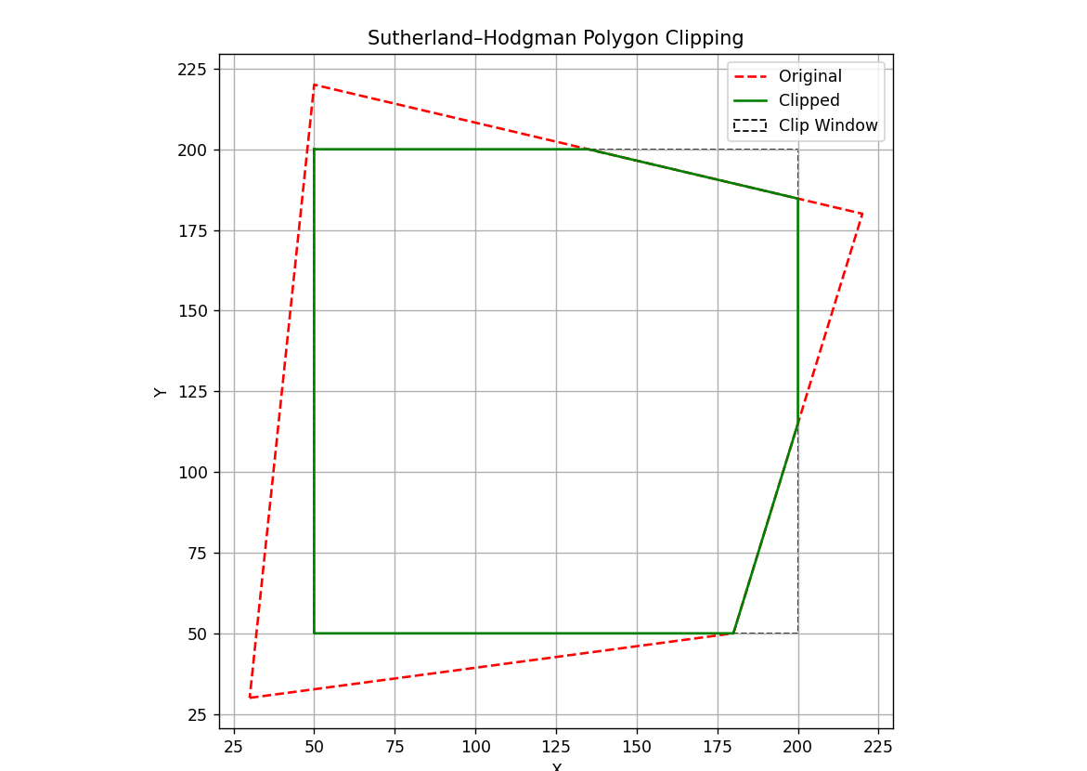

1. **WAP to apply various 2D Transformations on a 2D object.**

import numpy as np

import matplotlib.pyplot as plt

def get_polygon():

    n = int(input("Enter number of vertices: "))

    return np.array([[*map(float, input(f"x[{i+1}] y[{i+1}]: ").split()), 1] for i in range(n)])

def transform(p, mat): return p @ mat.T

def matrices():

    return {

        '1': lambda: np.array([[1, 0, float(input("tx: "))], [0, 1, float(input("ty: "))], [0, 0, 1]]),

        '2': lambda: np.array([[float(input("sx: ")), 0, 0], [0, float(input("sy: ")), 0], [0, 0, 1]]),

        '3': lambda: (lambda a: np.array([[np.cos(a), -np.sin(a), 0], [np.sin(a), np.cos(a), 0], [0, 0, 1]]))(np.radians(float(input("Angle (deg): ")))),

        '4': lambda: np.array([[1, float(input("shx: ")), 0], [float(input("shy: ")), 1, 0], [0, 0, 1]]),

        '5': lambda: {'x': [[1, 0, 0], [0, -1, 0], [0, 0, 1]], 'y': [[-1, 0, 0], [0, 1, 0], [0, 0, 1]], 'origin': [[-1, 0, 0], [0, -1, 0], [0, 0, 1]]}[input("Axis (x/y/origin): ").lower()]

    }

def plot(polygon, transformed):

    def close(p): return np.vstack([p[:, :2], p[0, :2]])

    plt.clf()

    plt.plot(*close(polygon).T, 'ro--', label="Original")

    plt.plot(*close(transformed).T, 'go-', label="Transformed")

    plt.title("2D Transformation"); plt.xlabel("X"); plt.ylabel("Y")

    plt.legend(); plt.axis('equal'); plt.grid(True)

    plt.pause(0.1)

def main():

    print("2D Transformations using Homogeneous Coordinates")

    polygon = get_polygon()

    transformed = polygon.copy()

    plt.ion(); plt.figure()

    while True:

        print("\n1: Translate \n2: Scale \n3: Rotate \n4: Shear \n5: Reflect \nq: Quit")

        choice = input("Choose transformation: ")

        if choice == 'q': break

        if choice in matrices():

            try:

                mat = np.array(matrices()[choice](), dtype=float)

                transformed = transform(transformed, mat)

                plot(polygon, transformed)

            except: print("Invalid input.")

        else:

            print("Invalid choice.")

    plt.ioff(); plt.show()

if __name__ == "__main__":

    main()

**OUTPUT**

2D Transformations using Homogeneous Coordinates

Enter number of vertices: 4

x[1] y[1]: 0 0

x[2] y[2]: 1 0

x[3] y[3]: 1 1

x[4] y[4]: 0 1

1: Translate

2: Scale

3: Rotate

4: Shear

5: Reflect

q: Quit

Choose transformation: 3

Angle (deg): 45

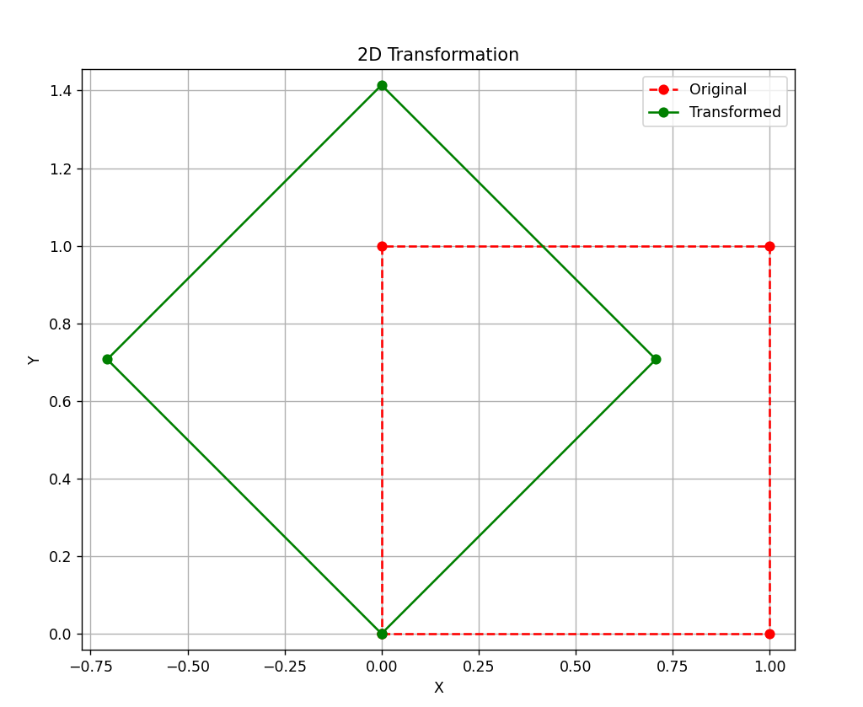

1. **WAP to draw Bezier and Hermite Curve.**

import numpy as np

import matplotlib.pyplot as plt

def bezier(P0, P1, P2, P3, t):

    return ((1 - t)**3)[:, None] * P0 + (3 * (1 - t)**2 * t)[:, None] * P1 + (3 * (1 - t) * t**2)[:, None] * P2 + (t**3)[:, None] * P3

def hermite(P0, P1, T0, T1, t):

    h1, h2 = (2*t**3 - 3*t**2 + 1)[:, None], (t**3 - 2*t**2 + t)[:, None]

    h3, h4 = (-2*t**3 + 3*t**2)[:, None], (t**3 - t**2)[:, None]

    return h1 * P0 + h2 * T0 + h3 * P1 + h4 * T1

def get_points(n, prompt): return [np.array(list(map(float, input(f"{prompt} {i+1}: ").split()))) for i in range(n)]

def plot_curve(ctrl, curve, name):

    plt.plot(*ctrl.T, 'ro--', label='Control Points')

    plt.plot(*curve.T, 'b-', label=f'{name} Curve')

    plt.title(f'{name} Curve'); plt.xlabel('X'); plt.ylabel('Y')

    plt.legend(); plt.grid(True); plt.axis('equal'); plt.show()

def main():

    print("1. Bezier Curve\n2. Hermite Curve")

    choice = input("Choose (1 or 2): "); t = np.linspace(0, 1, 100)

    if choice == '1':

        P = get_points(4, "Bezier Point")

        curve = bezier(*P, t); plot_curve(np.vstack(P), curve, "Bezier")

    elif choice == '2':

        P0, P1 = get_points(2, "Endpoint")

        T0, T1 = get_points(2, "Tangent")

        curve = hermite(P0, P1, T0, T1, t)

        plot_curve(np.vstack([P0, P1]), curve, "Hermite")

    else:

        print("Invalid choice.")

if __name__ == "__main__":

    main()

**OUTPUT**

**Bezier Curve**

1. Bezier Curve

2. Hermite Curve

Choose (1 or 2): 1

Bezier Point 1: 0 0

Bezier Point 2: 1 3

Bezier Point 3: 3 3

Bezier Point 4: 4 0

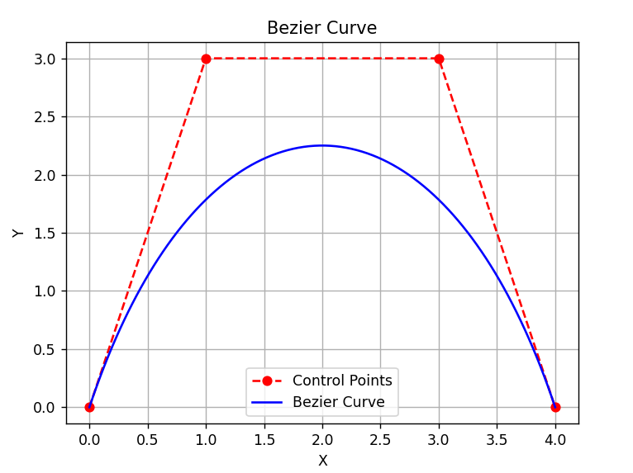

**Hermite Curve**

1. Bezier Curve

2. Hermite Curve

Choose (1 or 2): 2

Endpoint 1: 0 0

Endpoint 2: 4 0

Tangent 1: 1 3

Tangent 2: 1 -3

